Necklace

**by Isabel Stankiewicz**

Presenter Pack

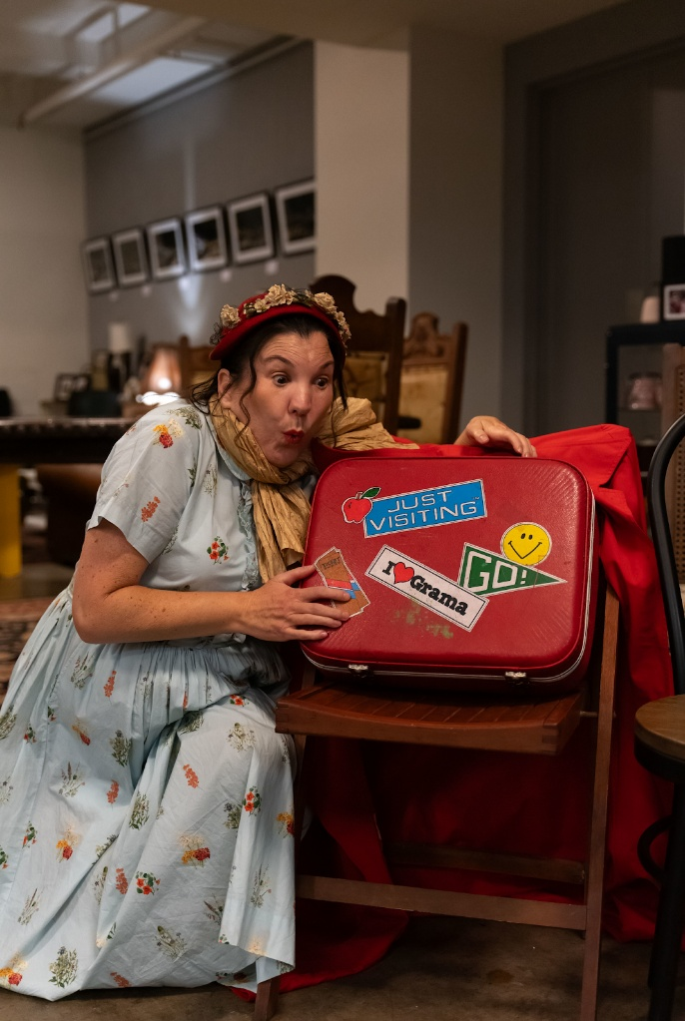

An image from the Anywhere Festival premiere in August 2024.

The host character leans in as if listening to a red suitcase seated on a chair.

Photo credit: Jade Ellis

Contents

Isabel Stankiewicz 5

Bio 5

Creatives 5

Necklace 6

Synopsis 6

Artform 6

Target Audience 6

Performance History 6

Touring Information 7

Availability to Tour 7

Duration 7

Suitable Venues 7

Touring Party 7

Maximum Performances 7

Minimum Break 7

APRA Obligations 7

Audience Engagement 8

Overview 8

Cost 8

Marketing Information 10

One liner 10

Short Copy 10

Extended Copy 10

Marketing Summary 10

Audience Reviews 11

Industry Recommendations 11

Archival 11

Content Warnings 11

Technical Information 12

Overview 12

Example Schedule 12

Technical Staffing 12

Staging 12

Lighting 12

Sound 12

Wardrobe 13

Freight 13

Contacts 13

Programming, technical, publicity 13

## Isabel Stankiewicz

### Bio

Isabel is a Brisbane based artist with disabilities.  Isabel premiered a sold out season of Necklace in 2024 held in the basement of Brisbane City Hall.  Isabel’s creative practice is informed by transformative, participatory processes and involves improvisation, song, movement, storytelling, poetry, and silence.  Performance highlights are Anywhere festival and a showcase at Undercover Artist: Online filmed at QLD Theatre.  Isabel holds a Master of Development Practice majoring in Community Development, Graduate Certificate of Disability and Inclusion, and Bachelor of Arts (majoring in theatre). Isabel’s work includes leading community development initiatives working with people with disabilities, children, seniors, adults and young people experiencing homelessness, and people experiencing and recovering from disasters in government and non-government contexts.  Isabel is a successful recipient of the Australia Council of the Arts Disability and Mentoring Initiative 2021, a High Commendation of the Access Arts Achievement Award in 2023.

**Isabel’s rationale for private presentations**

Necklace launches my career as an independent disabled theatre maker, extending and stretching me through new collaborations, networks, audiences, as well as new artistic, technical, and professional skills, experiences and knowledge. Undertaking private presentations is life changing for me, grounding my arts practice, and establishing this new chapter of my career in the field of disability, community and arts. *Necklace* is about overcoming my internalised ableism to embrace myself for who I am, a proud disabled artist and theorist. But it is also a transformational experience beyond my own, agitating audience perceptions of disability.

Through the sharing of my experiences and providing visible role modelling by premiering and performing *Necklace*, galvanises my original way of combining community development, theatre practice and working collaboratively for socio-economic and political social justice outcomes.

### Isabel worked with the following creatives through out the development of Necklace, click links to learn more:

[Freddy Komp](https://au.linkedin.com/in/freddy-komp-146a7a59)  Lighting and prop animation

Tracey Tanish Costuming

[Julie Robson](https://www.ladyfinger.com.au/)  Dramaturg mentor

[Dawn Albinger](https://www.ladyfinger.com.au/)  Dramaturg mentor

[Rob Pensalfini](https://qldshakespeare.org/rob-pensalfini/)  Audience engagement mentor

[Bree Hadley](https://research.qut.edu.au/c4ie/people/bree-hadley/)  Access and Inclusion mentor

[Harmonie Downes](https://au.linkedin.com/in/harmonie-downes)  Pitching and producing mentor

## Necklace

### Synopsis

Necklace is an intimate, autobiographical, and participatory performance exploring the experience of being treated and viewed as a burden on the medical system whilst bringing to light the joys, struggles and triumphs from diagnosis to acceptance. At turns funny and gutting, this story reminds us to be adventurers, always searching for the treasure within ourselves and others. This show will surprise and delight you and widen critical conversations about our perceptions of disability.  Join Isabel and her suitcase for an adventure you will not forget.

Necklace can be performed anywhere! So far audiences have enjoyed the show in a restaurant, antique store, a sauna, a tent, a community centre and a black box theatre.  Necklace is performed in the round - big or small, with bells and whistles or just Isabel, suitcase and a circle of chairs.

### Artform

* **Interactive**
* **Visual Theatre**

### Target Audience

* General Public
* Young people (12 +)
* People with disability
* Community, disability and health services sector

### Performance History

|  |  |  |
| --- | --- | --- |
| Year | Venue | Number of performances |
| 2024 | The Palm Hotel (Western Downs Regional Council) | 1 |
| 2024 | Brisbane City Hall (Anywhere Festival) | 4 |
| 2024 | Graham House Community Centre (Murgon) | 1 |
| 2024 | Kyabra Disability Services (Brisbane) | 1 |
| 2023 | The Sandstone Point Hotel Cellar (Qld Community Development Conference) | 1 |
| 2022 | Empire Revival (Anywhere Festival) | 2 |
| 2021 | Farrier Bar (Anywhere Festival) | 2 |
| 2020 | QLD Theatre (Undercover Artist: Online) | 1 |
| 2019 | High Spirits Retreat (LadyFinger performance retreat) | 1 |
|  |  |  |

## 

## Touring Information

### Availability to Tour

2025-2027

### Duration

60 minutes, interval optional in conjunction with community engagement activity.

### Suitable Venues

* Theatre - Arena / In-the-round
* Theatre - Black Box / Flat Floor
* Local Hall
* Found Spaces (i.e. temporary venues. converted rooms, bowls clubs)
* Cabaret (i.e. small theatre, bar, club with limited technical capacity)
* Site-specific: Necklace has been performed in a bar, café, antique store, tent, sauna

|  |  |  |
| --- | --- | --- |
| Touring Party | Maximum Performances | Minimum Break |
| 2 | 6 | 60 |
| ****pax**** | ****performances per week**** | ****minutes between performances**** |

### APRA Obligations

Necklace does include sound with APRA obligations, if these obligations aren’t able to be met an adaptation is in place.

## Audience Engagement

### Overview

Isabel is an experienced and well-respected community development arts practitioner holding a Master of Development Practice majoring in Community Development, a Graduate Certificate in Disability and Inclusion and a Bachelor of Arts. Isabel has led many community development arts based projects and spaces working with people with disabilities, people experiencing homelessness (including young people), Aboriginal and Torres Strait Islander people and people recovering from a disaster. Isabel's cultural legacy is to improve access and inclusion for people with disability. What will be left behind is knowledge about contemporary disability theory and practical access and inclusion skills.

Examples of engagement activities are:

1. 30 min Q & A following the show

2. 1-3 hour workshop including the following topics- Access and Inclusion, Community development, How to generate an autobiographical tale, Tailor- make.

Isabel does not require any additional resources/equipment for engagement activities.

Necklace community engagement highlights include:

1. Hosting an Anywhere Festival workshop for Independent Artists on how to embed inclusive practices.

2. Working with Western Downs Regional Council to widen conversations about disability and person centred emergency preparedness,

3. Presenting at the Qld Community Development conference, re-imagining social justice through autobiographical tales

4. Providing access and inclusion professional development to Kyabra Disability Services and Murgon Community Centre

|  |
| --- |
| 30 min Q & A |
| Widening the conversation about disability  Post presentation during a short break, audience members have the opportunity to write Isabel a postcard posing a question, reflection or comment. |
| Cost One off fee for presenter |
| **Target Audience**  General public, young people, community, disability and health services sector. This option is ideal for a 2 hour programming slot, show and Q & A. 60 mins presentation, 15 min break, 45 min for postcard writing, and a question-and-answer session with Isabel on widening the conversation about disability. |

|  |
| --- |
| 1-3 hour workshop |
| Topics include:  Access and Inclusion – learn about Isabel’s access and inclusion framework “The Compass” and how you can embed these practices and principles into your work.  Community development – learn about the community development practices and principles that underpin Necklace, including the Art of Hosting and Theatre of the Oppressed.  Generating your own autobiographical tale- join Isabel is a series of creative processes to generate concepts and content for your own tale. Walk away with a short performance piece.  Tailor made: eg person centred emergency preparedness. Partner with Isabel to co-design around a specific topic relevant to social justice outcomes for people with disability. |
| Cost One off fee for presenter |
| **Target Audience**  General public, young people, community, disability and health services sector. This option is ideal for a 3 hour programming slot. 60 mins presentation, 15 min break, 105 min for workshop. |

## Marketing Information

### One liner

Autobiographical tales from a forgotten suitcase.

### Short Copy

Necklace is an intimate, autobiographical and participatory performance exploring the experience of being treated and viewed as a burden on the medical system whilst bringing to light the joys, struggles and triumphs from diagnosis to acceptance. At turns funny and gutting, this story reminds us to be adventurers, always searching for the treasure within ourselves and others. This show will surprise and delight you and widen critical conversations about our perceptions of disability. Join Isabel and her suitcase for an adventure you will not forget.

### Extended Copy

Necklace is an intimate, autobiographical and participatory performance exploring the experience of being treated and viewed as a burden on the medical system whilst bringing to light the joys, struggles and triumphs from diagnosis to acceptance. At turns funny and gutting, this story reminds us to be adventurers, always searching for the treasure within ourselves and others. This show will surprise and delight you and widen critical conversations about our perceptions of disability. Join Isabel and her suitcase for an adventure you will not forget.  Necklace can be performed anywhere- so far audiences have enjoyed the show in a bar. a sauna, a tent and a black box theatre.  Necklace is performed in the round, big or small, lots of bells and whistles or just Isabel, suitcase and a circle of chairs.

### Marketing Summary

*"It is so important that we share our stories and it was so amazing to watch the faces of the audience as you shared yours. Audiences are hungry to share and to feel empathy and hope, you gave us room to do that. You were brave and splendid and held us in the palm of your hand."* Anywhere Festival 2024.

Through the sharing of my tale I galvanise my unique way of combining community development, theatre practice and working collaboratively for socio-economic and political social justice outcomes.

With the support of the Undercover Artist Online Showcase, Disability Arts Mentoring Initiative and the Access Arts Achievement Award Necklace has a range of resources available. These include:

1. Marketing, presenter and technical packs

2. Images

3. Promo footage- 1 min trailer, top to tail recording and a 3-scene excerpt with embedded audio description and auslan.

4. digital assets for socials

5. A published academic journal

### Audience Reviews

“A gem of a show… it zinged, danced, embraced, laughed, and loved. Thank you dear Isabel” ****Audience Member, Anywhere Festival 2024.****

**“Beautiful story, beautiful soul, beautiful work” **— Julie Robson, Ladyfinger, Anywhere Festival 2024.****

“To the core, you reached in.  You captured the treasures beautifully, thank you”****— Audience member, Anywhere Festival 2023.****

### Industry Recommendations

*“Charming, thought-provoking, poignant, and of great quality****.”*** – Under Cover Artist Festival director, 2020.

### Archival

Production Trailer: https://drive.google.com/file/d/1Zy2uLQGyOhd6LK8MG-nqh02-sw0vjFx6/view?usp=sharing

Production Images: https://drive.google.com/drive/folders/16e_zW59PREQbpqwB1HrPN77J3RiG7QwX?usp=sharing

Archival Video: https://drive.google.com/file/d/137sE3A66fnF6BIMDR8Ku8dp4zDEtHYp_/view?usp=sharing

### Content Warnings

Occasional coarse language

Strong disability themes

Ableism and bullying

## Technical Information

### Overview

Necklace requires chairs (number dependent on audience size) and a lapel mic in a black box setting or low set stage.   
  
Necklace has custom built lighting (including props) which requires one powerpoint.  Pre-recorded audio and a small smoke machine is embedded into Necklace props, a minimum of one hour between shows is required (to charge batteries).

### Example Schedule

Arrive 2 hours prior to the show and set up chairs, lights and simple props.  This can occur the day before if the space and schedule allows.

### Technical Staffing

****Venue to supply****

Venue to supply audience chairs that can be positioned in the round, 1 merchandise table, 1-2 lapel mics for large venues.  Venue to provide staffing to set/reset help pre- and post-show, arranging of chairs and lighting.

### Staging

Low set stage with chairs able to be moved (into a circle) that can be used in conjunction with a dating bank.

****Necklace to supply****

* **1 chair, animated props**

****Venue to supply****

* Minimum of 20 chairs that can be moved that can be used in conjunction with a dating bank.

### Lighting

Necklace has 8 custom built lights that do not require rigging.

****Necklace to supply****

* Lighting

****Venue to supply****

* Powerpoint, a venue that is able to be darkened.

### Sound

The sound elements of the show are embedded into the props which Isabel activates with a remote control. If the venue is large 1-2 lapel mics is recommended.

****Necklace to supply****

* Animated props

****Venue to supply****

* Access to power point to charge props between showings, 1-2 lapel mic for large venues.

### Wardrobe

Dressing room/space optional

****Necklace to supply****

* Costume

### Freight

Everything is in a suitcase and car that travels with me.

## Contacts

|  |  |
| --- | --- |
| Programming, technical, publicity | |
| Isabel Stankiewicz  0423911839  [delveintothedark@gmail.com.au](mailto:delveintothedark@gmail.com.au) |  |
| **primary contact** |  |